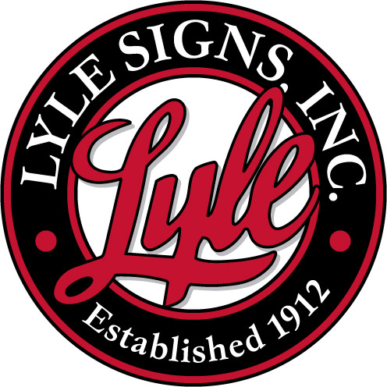
March 1, 2013
Arlington School Counselor
De Smet School Counselor
Iroquois School Counselor
Oldham-Ramona Counselor
Lake Preston Counselor

Subject: Lyle Signs Scholarship

Lyle Signs, Inc. is once again proud to make available four Scholarships to aid Kingsbury area students in post-secondary education.
- Two Scholarships at $1000
- Two Scholarships at $500

Eligibility Terms & Conditions:
- Applicants must be a 2012 graduate of one of five Kingsbury County High Schools.
  - All students of Oldham-Ramona included.
- Scholarships are non-renewable.
- Funds may be used at any post-secondary institution.
- Payments will be made to the student and institution upon successful completion of the 1st Semester of Full Time enrollment via the South Dakota Community Foundation.

Entry documents include:
- Application form (Must be signed by student, parent and school counselor)
- Essay Question Answers
- Transcript and/or Report Card (Seven Semesters)

Application material may be photocopied for distribution to students. A Lyle Signs, Inc. representative will make the Scholarship Presentation at each of the winning student’s Awards Assembly if possible. All entry documents are to be postmarked (or emailed) no later than April 1st, 2012 and mailed to the address listed below:

Lyle Signs, Inc.
ATTN: Scholarship Committee
PO Box 90
200 Industrial Park
De Smet, SD 57231

If you have any questions or need more information please contact Laird Beck at (605) 854-9191 Ext 104.
Also I would appreciate if you could just confirm receipt of this material by emailing me at: lairdbeck@lylesigns.com.

Thank you,
Laird Beck

VP/Plant Manager
Lyle Signs, Inc.

