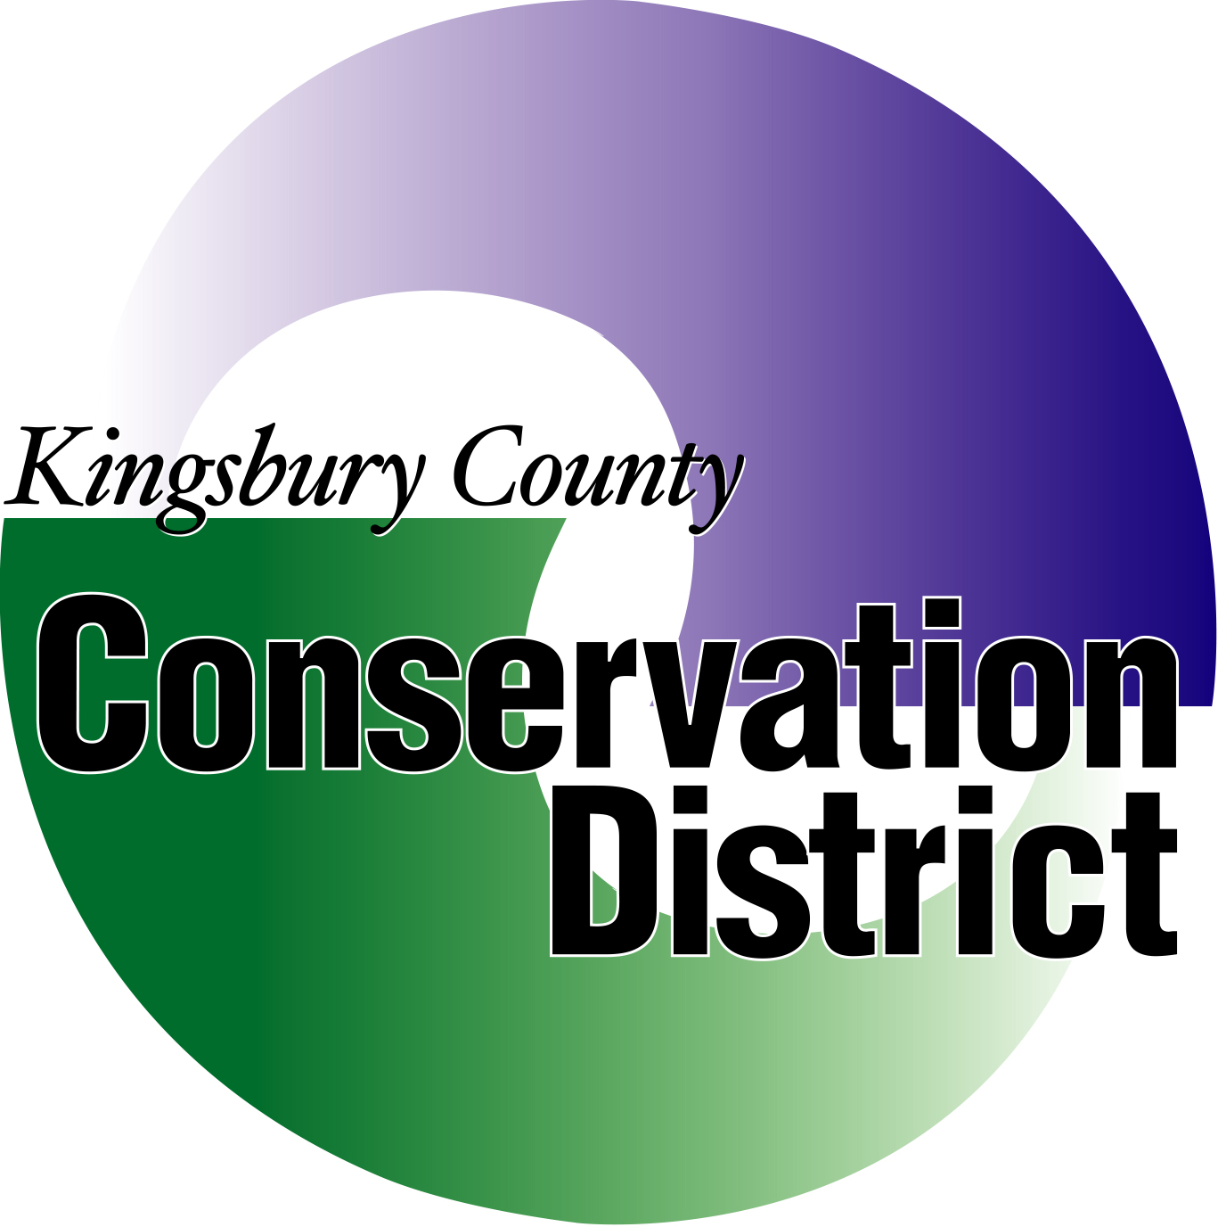
Kingsbury Conservation District Scholarship
Scholarship Application
MUST BE A RESIDENT OF KINGSBURY COUNTY
AND GOING INTO AN AG RELATED PROGRAM

The Kingsbury Conservation District will offer upto four $250 Scholarships. The amount will be paid upon completion of 2nd semester registration.

PLEASE FURNISH A COPY OF YOUR HIGH SCHOOL TRANSCRIPT

Student’s Full Name

- Student’s Address

Phone number
Email Address

- Name of Parents

(ATTACH ADDITIONAL SHEET(S) AS NEEDED FOR QUESTIONS 3-5)
- Awards, Honors, Offices in High School
__________________________________________________________________________________

- Extra Curricular & Community Activities, Honors
___________________________________________________________________________________

- Any awards, medals, or recognition earned relating to conservation

___________________________________________________________________________________

- College, University or Vocational School you plan to attend

- What major course of study do you intend to pursue?

ALL APPLICATIONS MUST BE POST-MARKED ON OR BEFORE MARCH 31 AND SENT TO:

KINGSBURY CONSERVATION DISTRICT
BOX 85
DE SMET, SD 57231-0085

Signature of Applicant Date

